**Due**: March 4

**Part 1 Goals (Part 2 will be added after next week’s lab)**

1. Stitch together basic skills in API queries with raster, cube, TIN, and Terrain data transformation steps to create an extract, transfer, and load system for LiDAR data from the Minnesota DNR’s FTP server.
2. Use ArcPro to perform side-by-side exploratory spatial data analysis using 2D and Scene views.
3. Use ArcPy to export to a PDF a visualization of LiDAR data

**Part 1 Deliverables**

Submit a lab report on Canvas as a PDF (see [report form](https://docs.google.com/document/u/0/d/1gOGBtTe3dQzrXCEMl644QIVdJgMp8ahN/?rtpof=true&usp=drive_fs)). Include all your code on GitHub as both .ipynb files and PDFs of the notebooks.

**Part 1 Specifics**

For this lab, write a lab report and create code that accomplishes the following:

1. Describe and build an ETL in ArcPro Jupyter Notebooks that
   1. Downloads .LAS files from MN DNR [1]
   2. Converts the .LAS file into both a DEM and a TIN
   3. Saves the new DEM and TIN to disk
   4. Exports PDFs of the DEM and TIN with correct visualization
2. Do side-by-side exploratory data analysis with a 2D map of the .las file on one pane and a 3D Scene of the .las file on another pane. This will be very computationally intensive, so use a small .las file. In your writeup, describe the features provided by ArcGIS for working with 2D and 3D visualization of .las files.
3. Describe and build an ETL in ArcPro Jupyter Notebooks that
   1. Downloads the annual 30-Year Normals .bil files for precipitation from PRISM [2]
   2. Converts the data into a spacetime cube and exports it to disk (see here for [example](https://pro.arcgis.com/en/pro-app/latest/tool-reference/space-time-pattern-mining/createcubefrommdrasterlayer.htm) of final conversion step; to get to this point, you will need to go through other transform steps likely) [3]
   3. Exports an animation of the timeseries

**[1]** DNR FTP server: <https://resources.gisdata.mn.gov/pub/data/elevation/lidar/> -- I recommend using their example .las datasets as they’re more reasonably sized.

**[2]** PRISM website: <https://prism.oregonstate.edu/normals/>

**[3]** This blog post will give you some inspiration as to why we are emphasizing spacetime cubes: <https://www.esri.com/arcgis-blog/products/arcgis-pro/analytics/explore-your-raster-data-with-space-time-pattern-mining/>

**Lab Report**

Title: Lab 2

Notice: Dr. Bryan Runck

Author: Cole Anderson

Date: 3/4/21

**Project Repository:** *<weblink to public repository>*

**Abstract**

*<Delete this text in light grey throughout>*

*250 words max. Clearly summarize the following major sections. Each gets one or two sentences.*

**Problem Statement**

*Describe the specific problem and the context. Provide an illustrative figure and/or context map here. In the table, translate the qualitative problem statement elements into specific requirements for the analysis.*

*Table 1. <insert caption>*

|  |  |  |  |  |  |  |
| --- | --- | --- | --- | --- | --- | --- |
| **#** | **Requirement** | **Defined As** | **Spatial Data** | **Attribute Data** | **Dataset** | **Preparation** |
| 1 | Download LAS file from DNR | Raw API pull from DNR FTP server | Road geometry |  | LAS File net location |  |
| 2 | Convert LAS to TIN/DEM and save to disk | <function> |  | Volume | LAS saved file |  |
| 3 | Export TIN/DEM properly visualized | <function> |  |  | TIN/DEM saved file |  |
| 4 | Compare 2 and 3D visualizations of LAS files | Comparison Criteria: |  |  | TIN/DEM saved file |  |
| 5 | Download BIL Files from PRISM |  |  |  | 30 Year Annuals |  |
| 6 | Transform to Space-cube, Export | <function>, <function> |  |  | BIL saved files |  |
| 7 | Export Time Series Animation | <function> |  |  | BIL saved files |  |

**Input Data**

*Describe the data in two paragraphs max. Fill out the table.*

*Table 2. <insert caption>*

|  |  |  |  |
| --- | --- | --- | --- |
| **#** | **Title** | **Purpose in Analysis** | **Link to Source** |
| 1 | Minnesota Roads | Raw input dataset for routing analysis from MNDOT | [Mn GeoSpatial Commons](https://gisdata.mn.gov/dataset/trans-roads-mndot-tis) |
| 2 |  |  |  |
| 3 |  |  |  |
|  |  |  |  |

**Methods**

*Include a data flow diagram or screenshot from model builder. Do references in line (Rammankutty, 2033). Document any and all steps that you did to the input data in the data flow diagram. Provide natural language description of the most important steps, giving a narrative arc and provide well formatting screenshots with a boarder and centered throughout.*

*Resources on Data Flow Diagrams:*

* [*https://www.visual-paradigm.com/tutorials/data-flow-diagram-dfd.jsp*](https://www.visual-paradigm.com/tutorials/data-flow-diagram-dfd.jsp)
* [*https://www.lucidchart.com/pages/data-flow-diagram/how-to-make-a-dfd*](https://www.lucidchart.com/pages/data-flow-diagram/how-to-make-a-dfd)

*Figure 1. Data flow diagram.*

**Results**

*Show the results in figures and maps. Describe how they address the problem statement.*

*Follow best practice for map design, coloring, etc.*

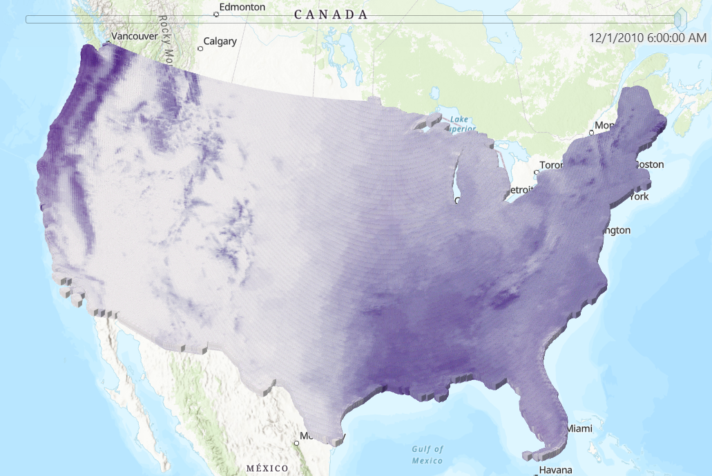

**Results Verification**

*How do you know your results are correct? This can be a qualitative or quantitative verification.*

**Discussion and Conclusion**

*What did you learn? How does it relate to the main problem?*

Notes on 3d/2d LAS visualization

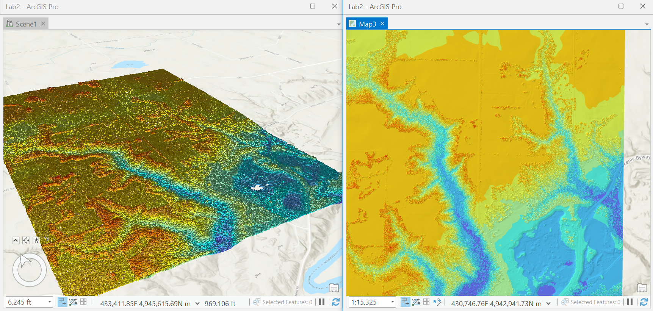

Can adjust point density on both: more min density = coarser

Can adjust lightinh on Scene

Change symbology to show elevation, slope, or aspect values with surfaces

Change symbology to show elevations, LAS classification code, lidar pulse return, RGB values, intensity values with points

Change symbology to show edges, contour lines using lines

Functions on both: area/volume, height metrics, locate outliers, surface derivatives (aspect, contour, slope), visibility (line of sight), adjust classification

Scene: can create a slice profile

**References**

*Use a common format*

**Self-score**

*Fill out this rubric for yourself and include it in your lab report. The same rubric will be used to generate a grade in proportion to the points assigned in the syllabus to the assignment.*

|  |  |  |  |
| --- | --- | --- | --- |
| **Category** | **Description** | **Points Possible** | **Score** |
| **Structural Elements** | All elements of a lab report are included **(2 points each)**:  Title, Notice: Dr. Bryan Runck, Author, Project Repository, Date, Abstract, Problem Statement, Input Data w/ tables, Methods w/ Data, Flow Diagrams, Results, Results Verification, Discussion and Conclusion, References in common format, Self-score | 28 |  |
| **Clarity of Content** | Each element above is executed at a professional level so that someone can understand the goal, data, methods, results, and their validity and implications in a 5 minute reading at a cursory-level, and in a 30 minute meeting at a deep level **(12 points)**. There is a clear connection from data to results to discussion and conclusion **(12 points)**. | 24 |  |
| **Reproducibility** | Results are completely reproducible by someone with basic GIS training. There is no ambiguity in data flow or rationale for data operations. Every step is documented and justified. | 28 |  |
| **Verification** | Results are correct in that they have been verified in comparison to some standard. The standard is clearly stated **(10 points)**, the method of comparison is clearly stated **(5 points)**, and the result of verification is clearly stated **(5 points)**. | 20 |  |
|  |  | 100 |  |